D1_Nihar_84066

ASSIGNMENT 1
creating sample tables and inserting values
create table SALESPEOPLE
(
Snum int(4),
Sname varchar(10),
City varchar(10),
Comm float(3,2)
);

create table CUSTOMERS
(
Cnum int(4),
Cname varchar(10),
City varchar(10),
Rating int(4),
Snum int(4)
);

create table ORDERS
(
Onum int(4),
Amt float(7,2),
Odate date,
Cnum int(4),
Snum int(4)
);

insert into SALESPEOPLE values
(1001,’Peel’, ’London’, .12),
(1002, ‘Serres’ , ‘San Jose’, .13),
1004, ‘Motika’, ‘London’, .11),
(1007, ‘Rifkin’, ‘Barcelona’, .15),
(1003, ‘Axelrod, ‘New York’, .10);
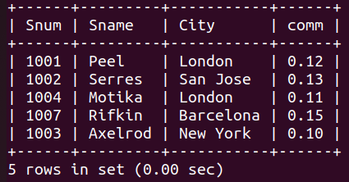
D1_nihar_84066>select * from SALESPEOPLE;

insert into CUSTOMERS values
(2001,’Hoffman’, ‘London’, 100, 1001),
(2002, ‘Giovanni’, ‘Rome’, 200, 1003),
(2003, ‘Liu’, ‘San Jose’, 200, 1003),
(2004, ‘Grass’, ‘Berlin’, 300, 1002),
(2006, ‘Clemens’, ‘London’, 100, 1001),
(2008, ‘Cisneros’, ‘San Jose’, 300, 1007),
(2007, ‘Pereira’, ‘Rome’, 100, 1004);
D1_nihar_84066>select * from CUSTOMERS;
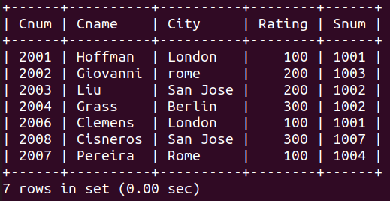

insert into ORDERS values
(3001, 18.69, ‘1990-10-03’, 2008, 1007),
(3003, 767.19, ‘1990-10-03’, 2001, 1001),
(3002, 1900.10, ‘1990-10-03’, 2007, 1004),
(3005, 5160.45, ‘1990-10-03’, 2003, 1002),
(3006, 1098.16, ‘1990-10-03’, 2008, 1007),
(3009,1713.23, ‘1990-10-04’, 2002, 1003),
(3007, 75.75, ‘1990-10-04’, 2004, 1002),
(3008, 4723.00, ‘1990-10-05’, 2006, 1001),
(3010, 1309.95, ‘1990-10-06’, 2004, 1002),
(3011, 9891.88, ‘1990-10-06’, 2006, 1001);
D1_nihar_84066>select * from ORDERS;
